**Power BI Assignment 5**

--------------------------------------------------------------------------------------------------------------------------------------

Q1:- Explain DAX.

Ans:- Dax means (Data Analysis Expressions) is the formula expression language can be used for Calculated columns or measures, DAX is very helpful to perform complex calculations on large amount of data, It’s much more faster than traditional excel formulas.

Knowing DAX is very important for any Data Analyst in Power BI.

--------------------------------------------------------------------------------------------------------------------------------------

Q2:- Explain datasets, reports, and dashboards and how they relate to each other?

Ans:-

* Datasets:- Datasets is the collection of data in rows and columns which we can use for any data analysis, The datasets is must be clean with No error. There are multiple types of Dataset such as Table, Links, Trees, Network, Geo-spatial etc.
* Reports:- Report in power BI is is a page or series of pages which contains multiple tiles depicting some values or graphs in form of visualizations which are colourful and interactive.
* Dashboards:- Dashboards are also a form of reports. The unique thing is it a summarized form of report. It contains the same elements as reports have. But the important key information alone is added to dashboard from multiple reports. For example, we may create multiple indivudual reports on Facebook, Instragram, LinkedIn data how people interact with our Business page. A Dashboard is an smaller form of report which has more information in an smaller area.
* All these 3 things are important for any data complete data analysis.

--------------------------------------------------------------------------------------------------------------------------------------

Q3:- How reports can be created in power BI, explain two ways with Navigation of each.

Ans:- There are 3 primary sections in home page which is used to create contents in Reports

Canvas - The center blank white is the canvas where visuals will appear

Fields Pane - Contains queries and columns of the dataset

Visualization Pane - To edit and format visualizations

Reports can be created in two ways

Select the fields first then visualizations after

Select the type of visual first then the fields after

METHOD 1

Step 1 - Select 2 columns from Field Pane to visualize the data in 2D chart.

Step 2 - When clicking them, a suitable visual will appear in the canvas area.

Step 3 - Drag them and position them properly. Use formatting options in Visualization Pane for Customization.

Step 4 - If you want to change the type of graph, select the chart tile in canvas and click the required type of graph in Visualization Pane.

METHOD 2

Step 1 - Select the chart type. An empty tile will appear in Canvas.

Step 2 - Click and drag the Columns to Fields and Values field in Visualization pane.

Step 3 - If we want to categorize the 2D plot with category as 3rd Dimension, the drop the column in Legend Field

step 4 - Use formatting options in Visualization Pane for Customization.

Now save and publish the report in Power BI Services.

--------------------------------------------------------------------------------------------------------------------------------------

Q4:- How to connect to data in Power BI? How to use the content pack to connect to google analytics? Mention the steps.

And:- To Connect to a Data source, click on "Get Data" option in Home Tab. Select the respective Data source. There are multiple sources of data to connect with, i.e, to Database or Cloud or Local File etc., Given below is the screenshot of Getting Data from a web source. image

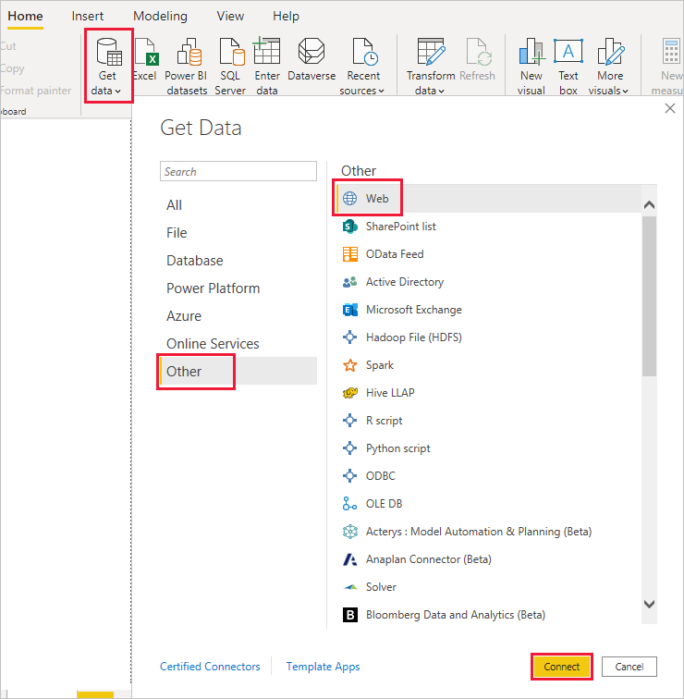

Using Content Pack to Connect to Google Analytics

image

In the left navigation pane, click Get Data. image



In the Services box, click Get. image

From the menu of online services, select Google Analytics, and then click Connect. image

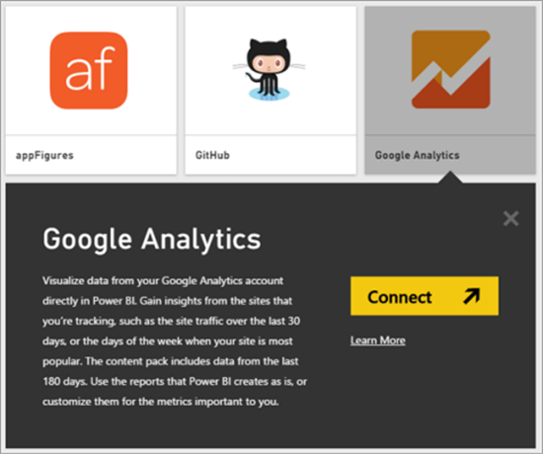

Enter the Google Analytics account, property, and view that you want to connect to. Then sign in with your Google Analytics credentials. image

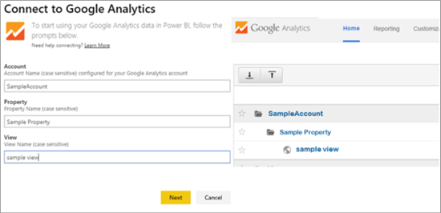

To permit Power BI to connect to Google Analytics, click Accept. image

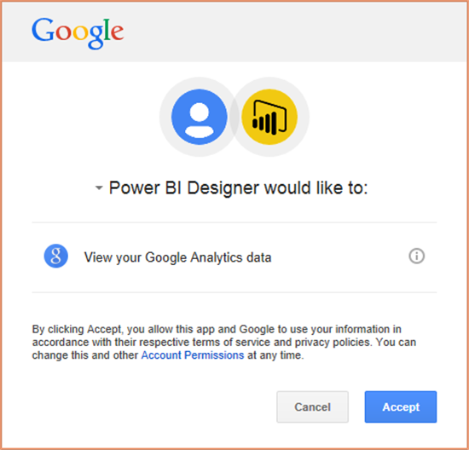

When the import process completes, you will see a new dashboard, report, and model in the Navigation Pane. Select the dashboard to view your imported data. image

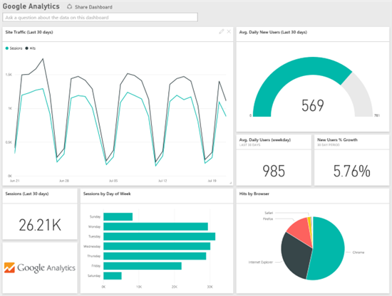

--------------------------------------------------------------------------------------------------------------------------------------

Q5:- How to import Local files in Power BI? Mention the Steps.

Ans:- Power BI has a powerful feature, it enables you to get data from a folder that contains multiple files. In this article, you will learn how to import data from multiple files located in the folder.

Step1:-

To import data, go to the ‘Home’ tab click on ‘Get data’ select the ‘Folder’ source then click ‘OK’. 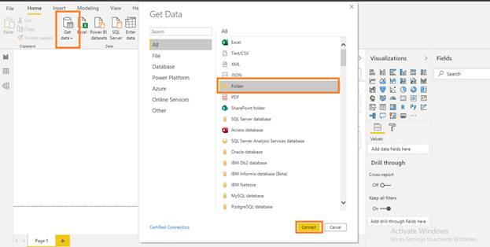

Paste the path of the folder and click OK.

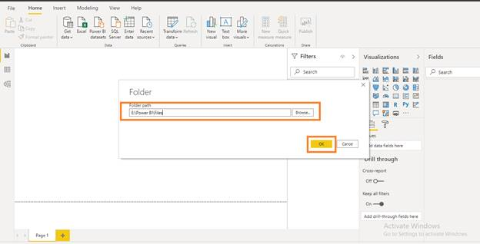

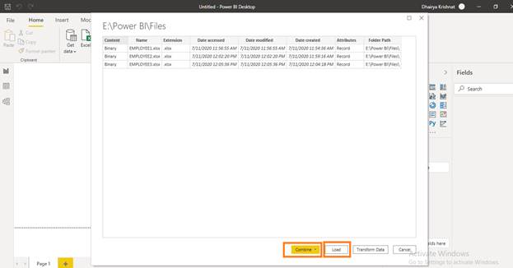

Here you can see the metadata information of all three files also you can see the four options ‘Combine’, ‘Load’, ‘transform Data’ and ‘Cancel’.

Step2:-

Once you click on ‘Combine & Load’ you get the option sample file, choose the file you want to load here.

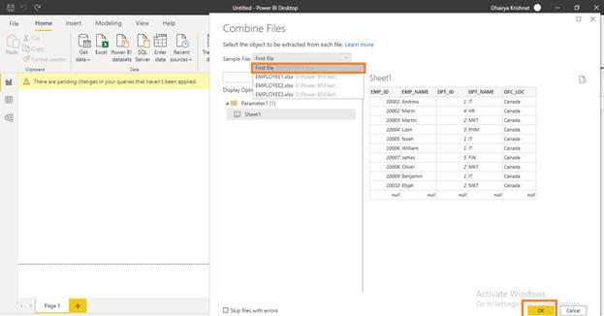

Your file has loaded now you can see the file on the left side of the tool.

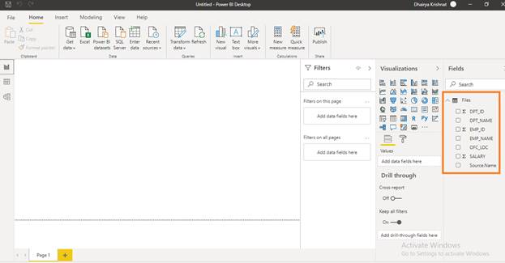

--------------------------------------------------------------------------------------------------------------------------------------

Q6:- In Power BI visualization, what are Reading View and Editing view?

Ans:- There are two modes of interacting with the visualizing in reports

* In Reading mode, users can only view or interact with the published reports in Power BI service. Clients in the workspace are restricted with Reading mode. But still users can view the visualizations changing dynamically, identify patterns/trend, get insights, query the reports.
* Editing mode is generally used by Report designers or Analysts who collect data and create reports. Only they can add or delete tiles or visualizations from the reports. A much of modification priviledge is granted in this view.

---------------------------------------------------------------------------------------------------------------------------